Meno a priezvisko: ..................................................................... Trieda: ...................

- Vypočítaj:

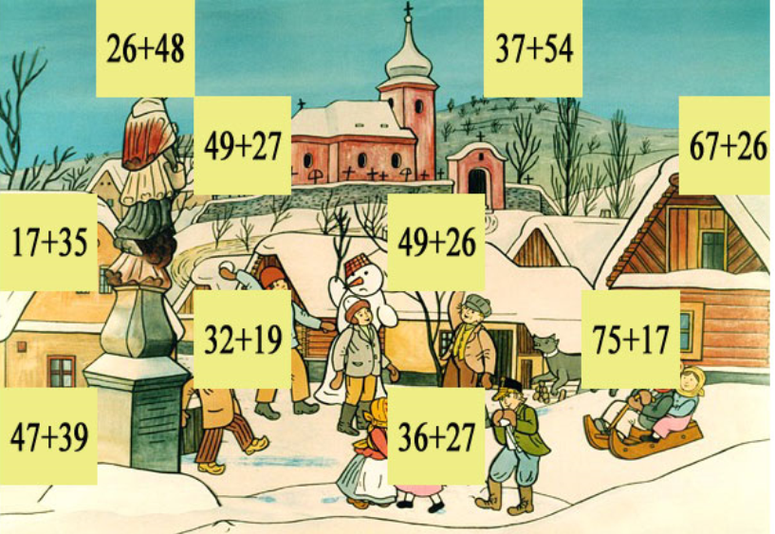

........................................................................................................................................

........................................................................................................................................

........................................................................................................................................

- Vynásob:

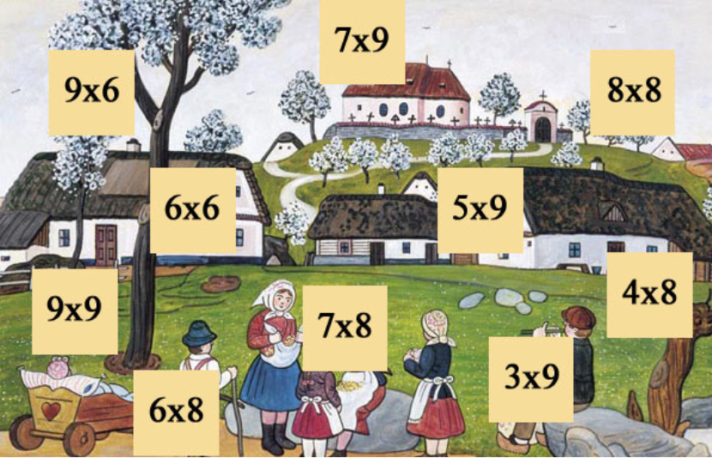

........................................................................................................................................

........................................................................................................................................

........................................................................................................................................

........................................................................................................................................

........................................................................................................................................

- Deľte:












